Quadratic Graphs
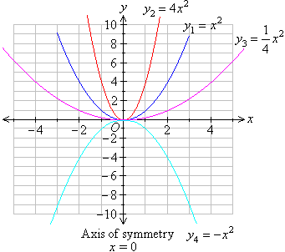

a. Complete the table for y = x² - 3x
and plot the graph on the opposite
grid.
.
x | -1 | 0 | 1 | 2 | 3 | 4
x²
-3x
y

- What are the coordinates of the
lowest point on the graph.

a. Complete this table for y = x² – 4x – 3
and plot the graph on the opposite grid.

x | -1 | 0 | 1 | 2 | 3 | 4 | 5
x²
-4x
-3
y

- What are the coordinates of the
lowest point on the graph.

Quadratic Graphs - Extension

- Complete the following table for
y = 2x² – 3x – 4 and plot the graph on
the opposite grid.
x | -1 | 0 | 1 | 2 | 3
x²
2x²
-3x
-4
y
- Write down the coordinates of the
lowest point of the graph.

- Build your own table for y = -x² -2x + 4

- Draw the graph of y = -x² -2x + 4 on
the same grid opposite.

- What can you say about the shapes of
the two graphs and why?

4) Below is a table of values for equation
y = x² + 4x – 1
x | -5 | -4 | -3 | -2 | -1 | 0 | 1 | 2
y | 4 |  | -4

- Fill in the missing values of y in the
table.

- On the opposite grid, draw the graph
of y = x² + 4x – 1

- From the graph estimate the values
of x for which y = 2
x = .................
x = ...................

